1. **Fig 1**

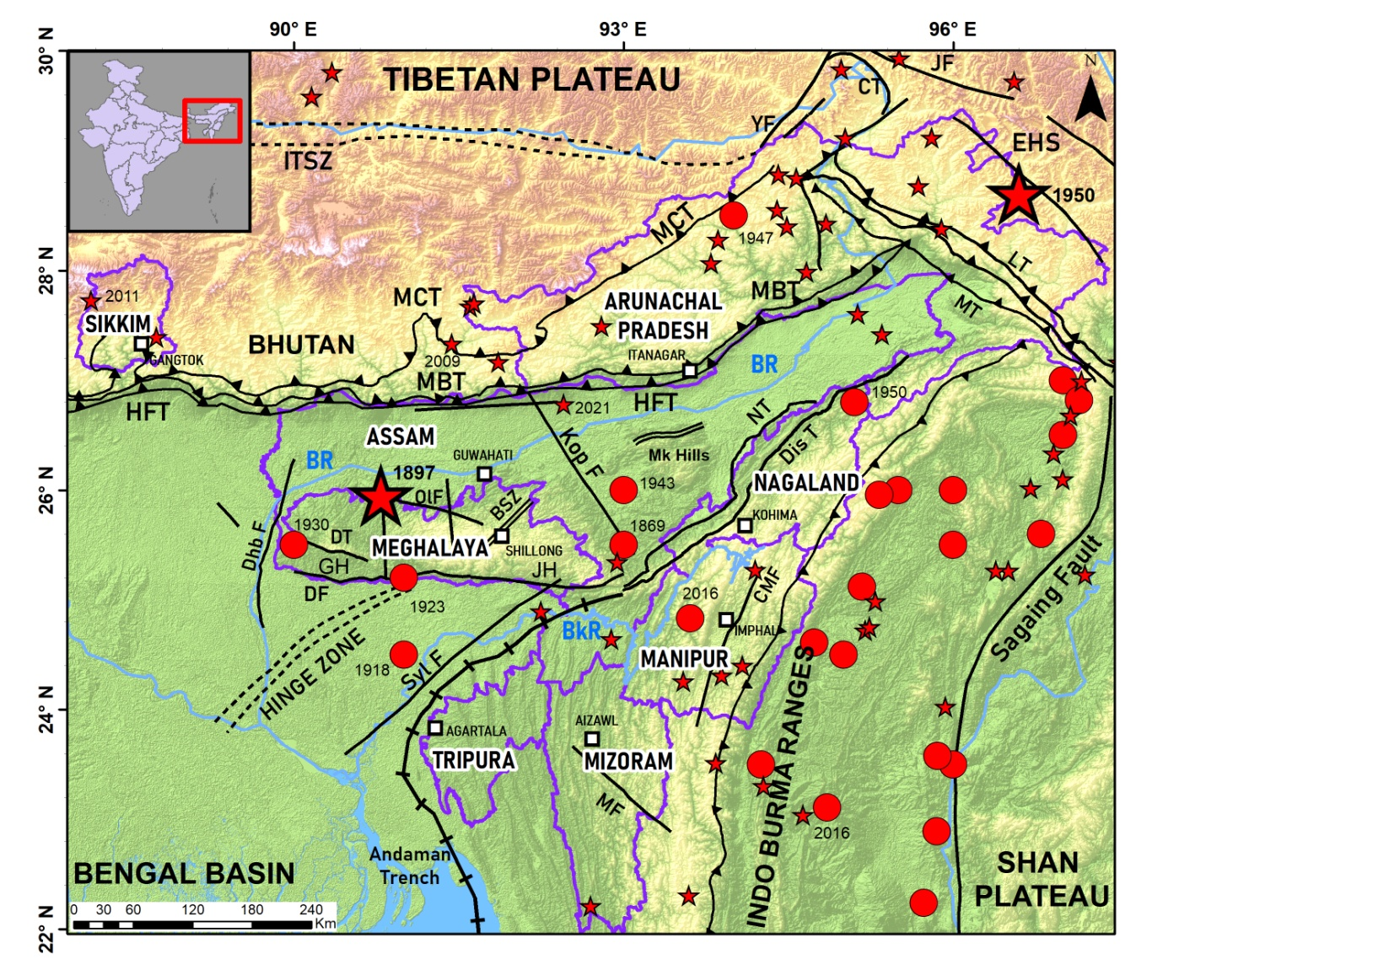

**Fig 1**. Geo-environmental set up of the NER, India. Base layers taken from NESDR, NESAC database. The SRTM elevation data are of 500 mspatial resolution. Epicentres of the great, large and strong earthquakes (ISC Catalog) are shown in the map.Two great earthquakes (Mw > 8.0) are shown by largest red stars, large earthquakes (Mw > 7.0) by red circles and strong earthquakes (Mw 6.0 - < 7.0) by smaller red stars. Major faults and tectonic features are drawn from EO data taking reference from the published Seismotectonic Atlas (GSI. 2000). These are: MCT: Main Central Thrust, MBT: Main Boundary Thrust.MT: Mishmi Trust, EHS: Eastern Himalaya Syntaxis, NT: Naga Thrust, EBT: East Boundary Thrust, SF: Sagaing Fault, KF: Kopili Fault, OF: Oldham Fault, DF: Dauki Fault, DbF. Dhubri Fault, HZ: Hinge zone etc. Inset: Key map, rectangle indicates the study region.